***Dt : 27/4/2022***

***faq:***

***wt is the diff b/w***

***(i)JDK***

***(ii)JRE***

***(i)JDK:***

***=>JDK stands for 'Java development Kit' and which provide***

***the following:***

***(a)Java Compiler***

***(b)Java Library***

***(c)JVM***

***(a)Java Compiler:***

***=>Java Compiler will compile the source code and generate***

***Byte code.***

***(b)Java Library:***

***=>Java Library will hold Pre-defined programming components***

***which can be used in application development.***

***=>we use 'java' word to represent JavaLibrary.***

***=>JavaLib will hold 'packages'.***

***=>packages will hold 'Classes and Interfaces'.***

***=>Classes and Interfaces will hold 'Variables and Methods'***

***Diagram:***

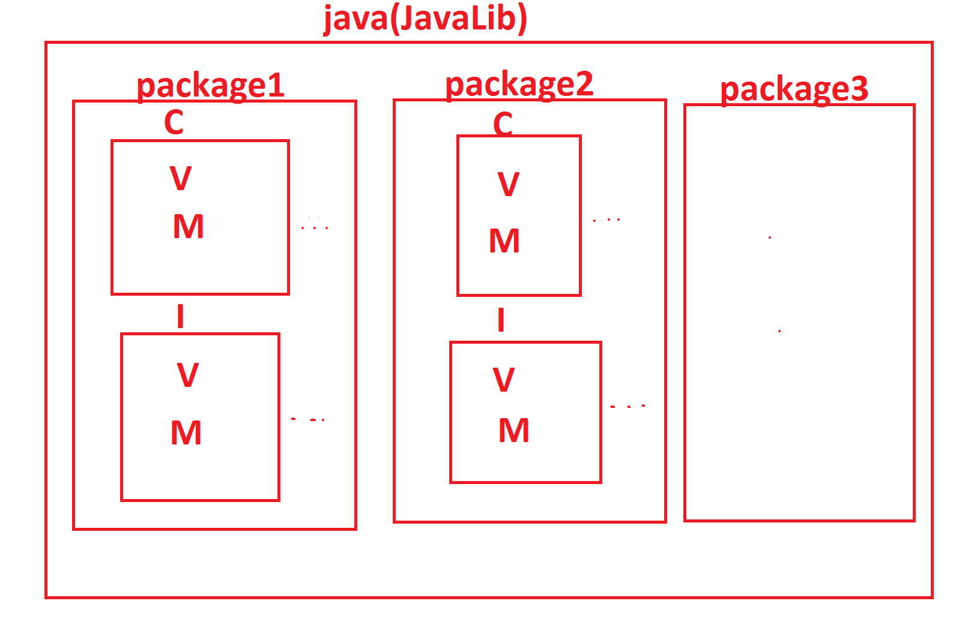

***=>The following are some important packages from JavaLib:***

***CoreJava packages:***

***(i)java.lang - Language package***

***(ii)java.util - Utility package***

***(iii)java.io - Streams and Files package***

***(iv)java.net - Networking package***

***AdvJava packages:***

***(i)java.sql - DataBase connection package***

***(ii)javax.servlet - Servlet Programming package***

***(iii)javax.servlet.jsp - JSP programming package***

***-------------------------------------------------------***

***\*imp***

***(c)JVM:***

***=>JVM stands for 'Java Virtual Machine' and which is used***

***to execute JavaByteCode.***

***=>JVM internally having the following three partitions:***

***(i)Class Loader SubSystem***

***(ii)Runtime Data Area***

***(iii)Execution Engine***

***Diagram:***

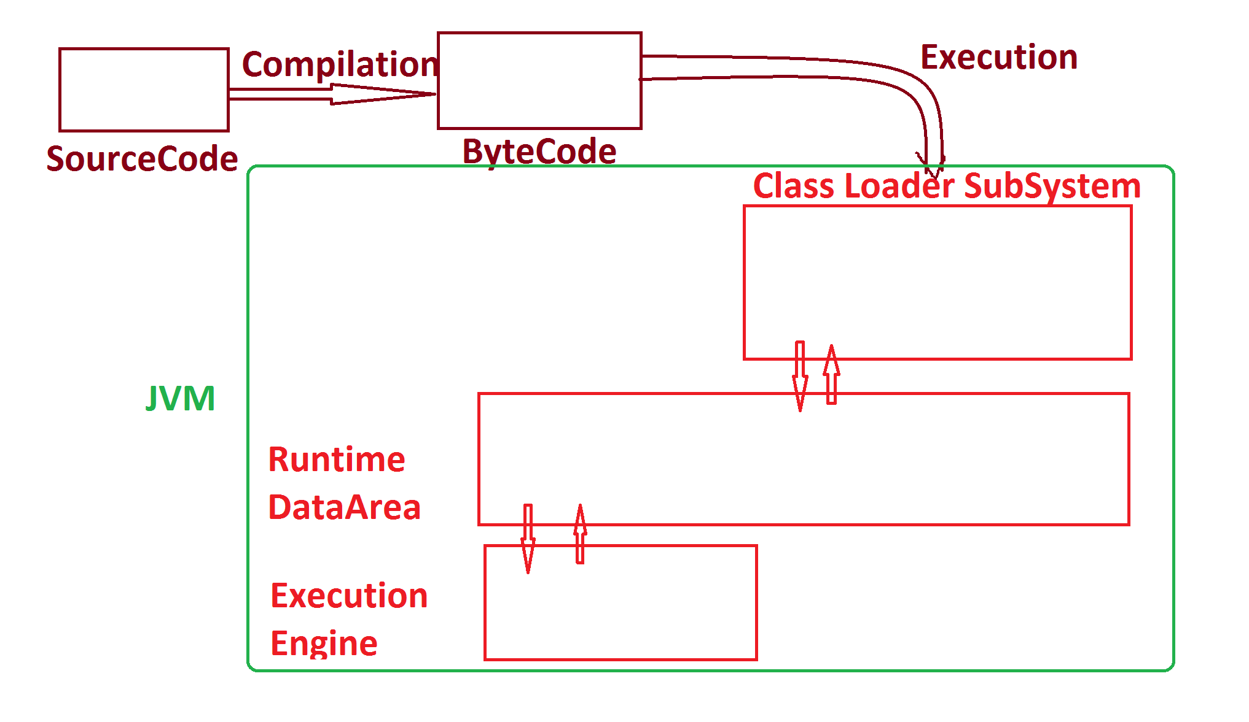

***--------------------------------------------------------***

***faq:***

***define Virtual Machine?***

***=>The s/w component which internally having the behaviour***

***like machine is known Virtual Machine.***

***=============================================================***

***(ii)JRE:***

***=>JRE stands for 'Java Runtime Environment' and which***

***provide 'JavaLib and JVM'.***

***=>JRE is inbuilt in JDK,which means part of JDK.***

***=>On demand we can download JRE separatly and which can be***

***used part of WebServers like Tomcat.***

***======================================================***

